PROJECT TITLE

### College Name: PPG COLLEGE OF ARTS AND SCIENCE

College Code: bruap

TEAM ID: NM2O25TMID25883

TEAM MEMBERS: 4

Team LeaderName: sWETHA.R

Email: 2326jO242.casoppg.edu.in

Team Member1: UDHAYAKUMAR.K

Email: 2326jO244.casoppg.edu.in

Team Member: TAMILSELVAN.S

Email: 2326jO243.casoppg.edu.in

Team Member: sWATHI.S

Email: 2326jO241.casoppg.edu.in

# INTRODUCTION

* 1. Project Overview

The Lease Management System is a Salesforce-based application designed to streamline the processes associated with leasing real estate properties. It handles tenant management, lease

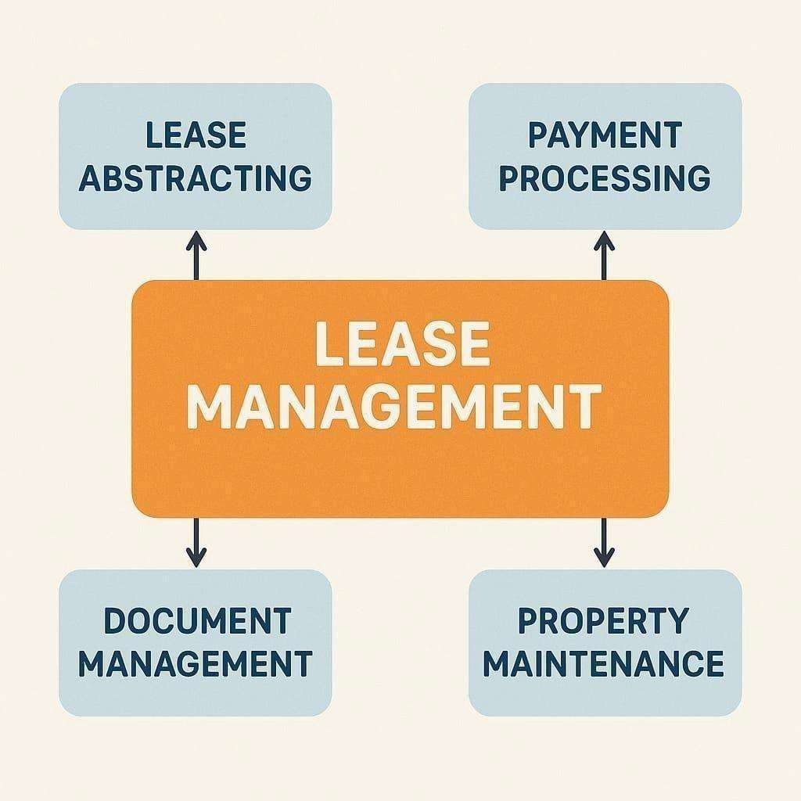contracts, payments, and communication with automation features such as flows, approval processes, and email alerts.

## Purpose

The main objective of the project is to enable organizations to efficiently manage properties, tenants, and lease-related activities. It reduces manual intervention, improves accuracy, and ensures better compliance and communication.

# DEVELOPMENT PHASE

Creating Developer Account:

By using this URL - [https://www.salesforce.com/form/developer-signup/?d=pb](http://www.salesforce.com/form/developer-signup/?d=pb)

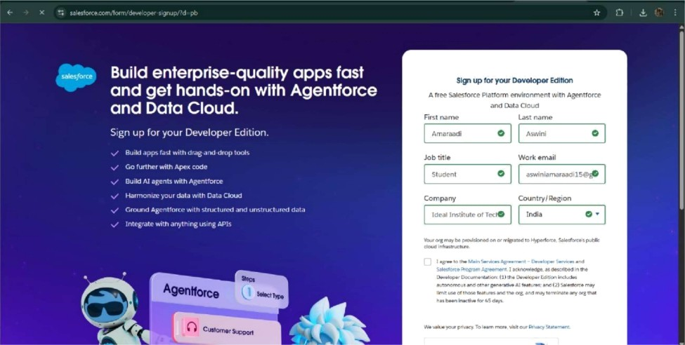

* + - Created objects: Property, Tenant, Lease, Payment



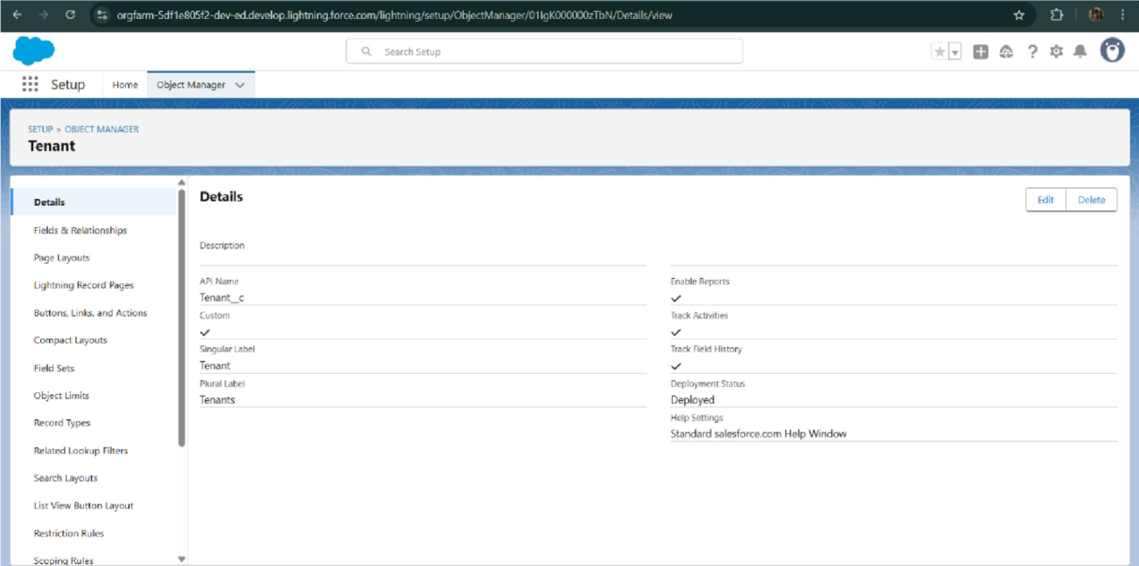

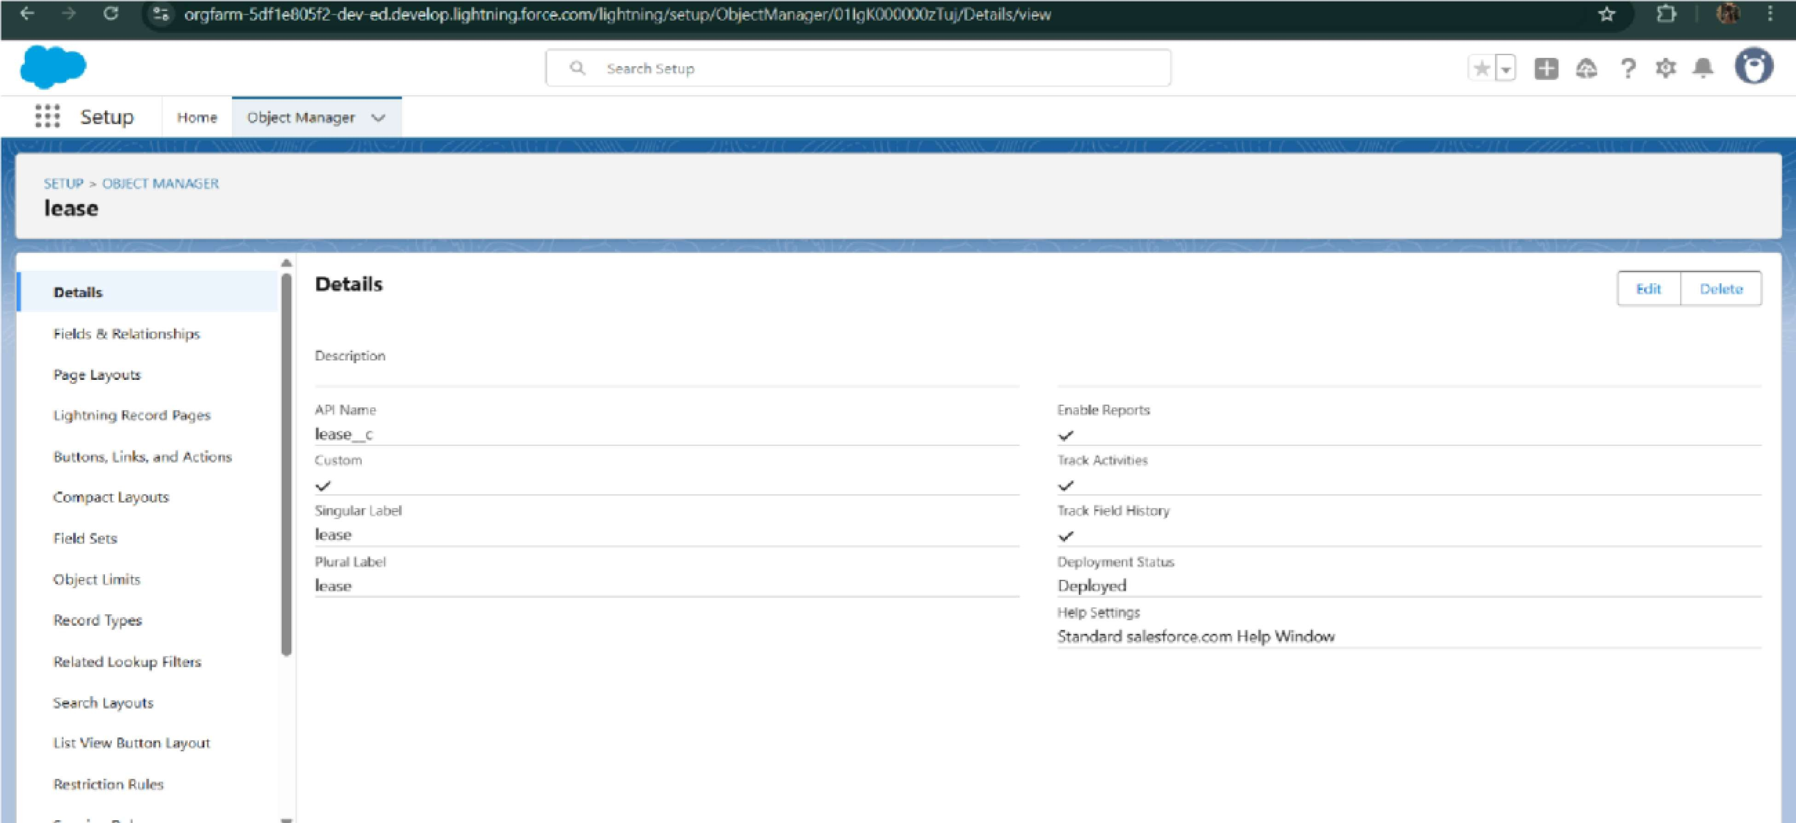



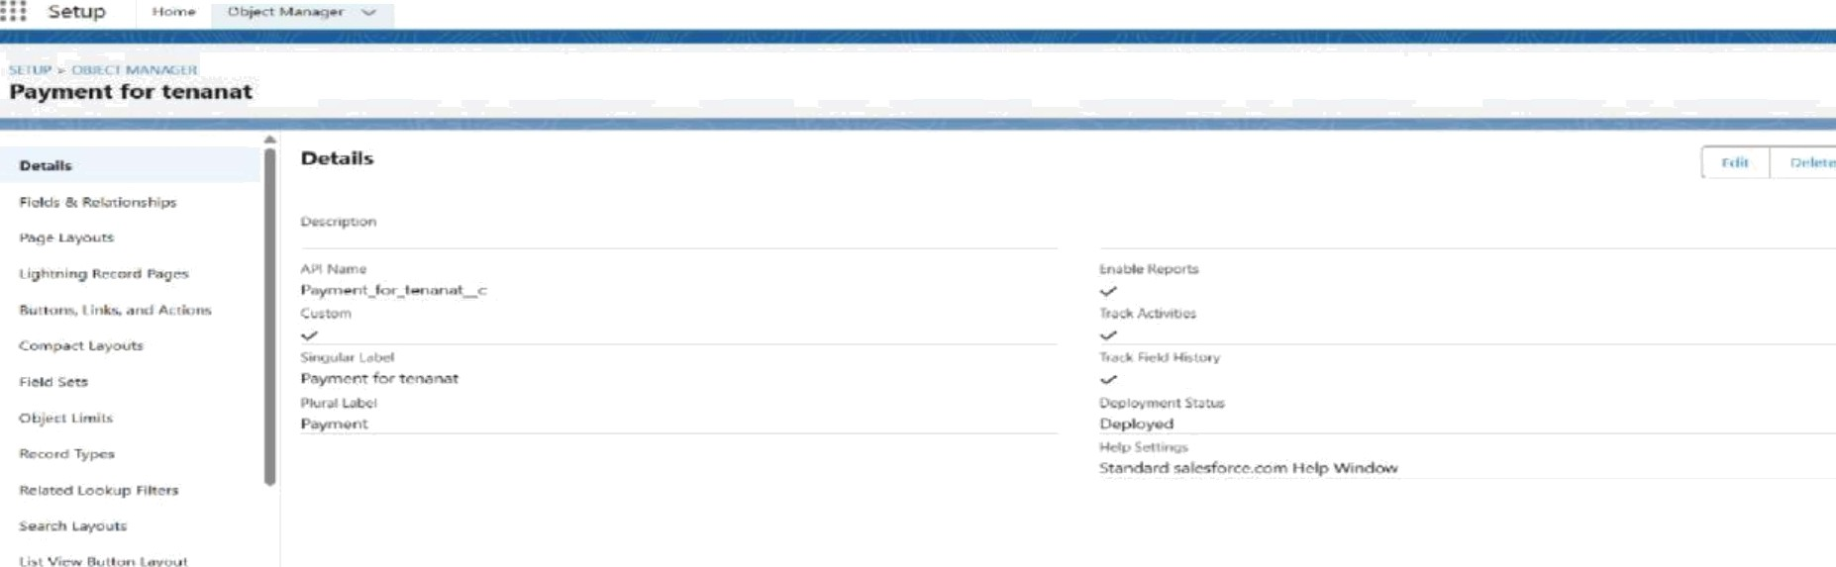

* + - Configured fields and relationships



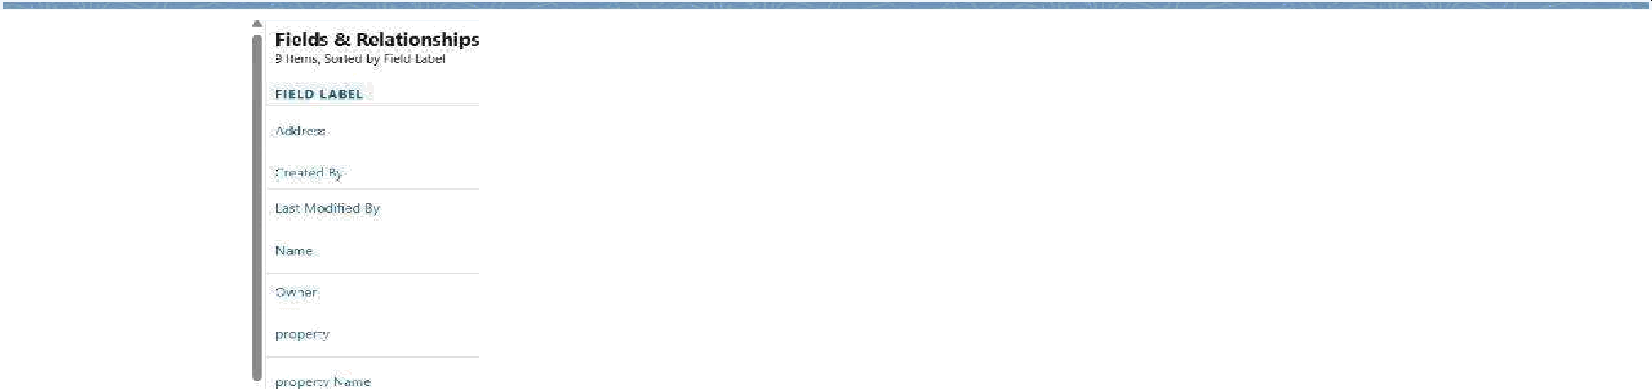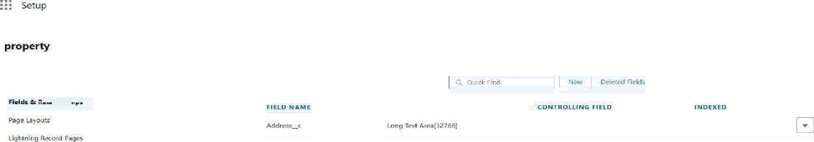

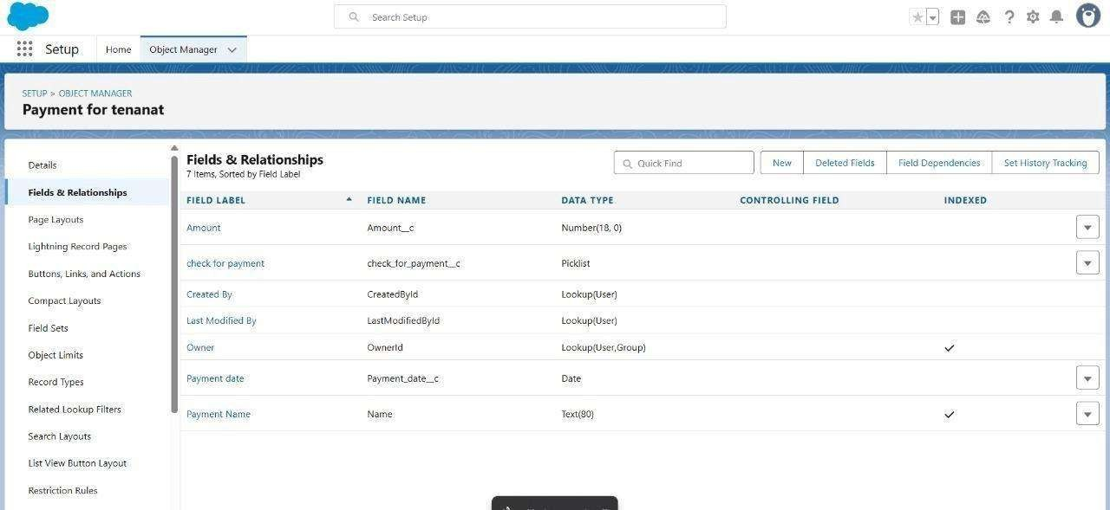

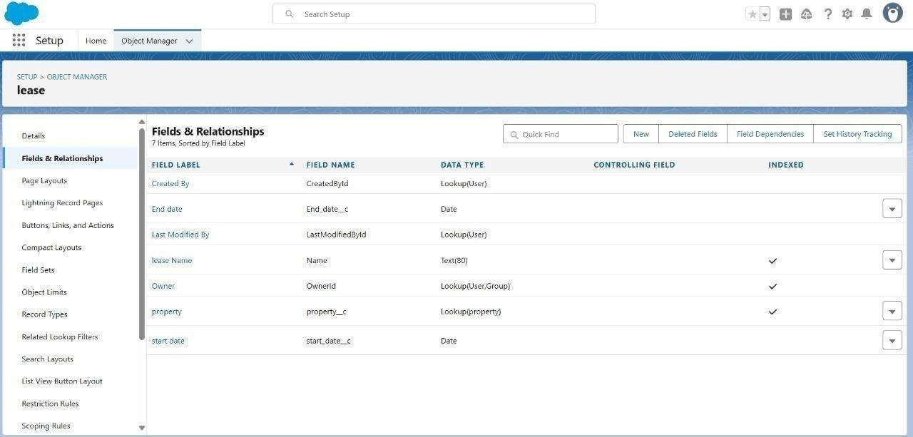



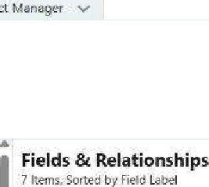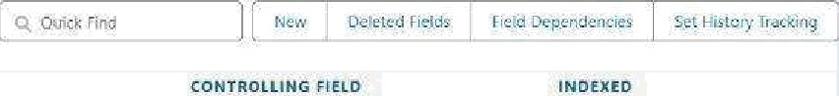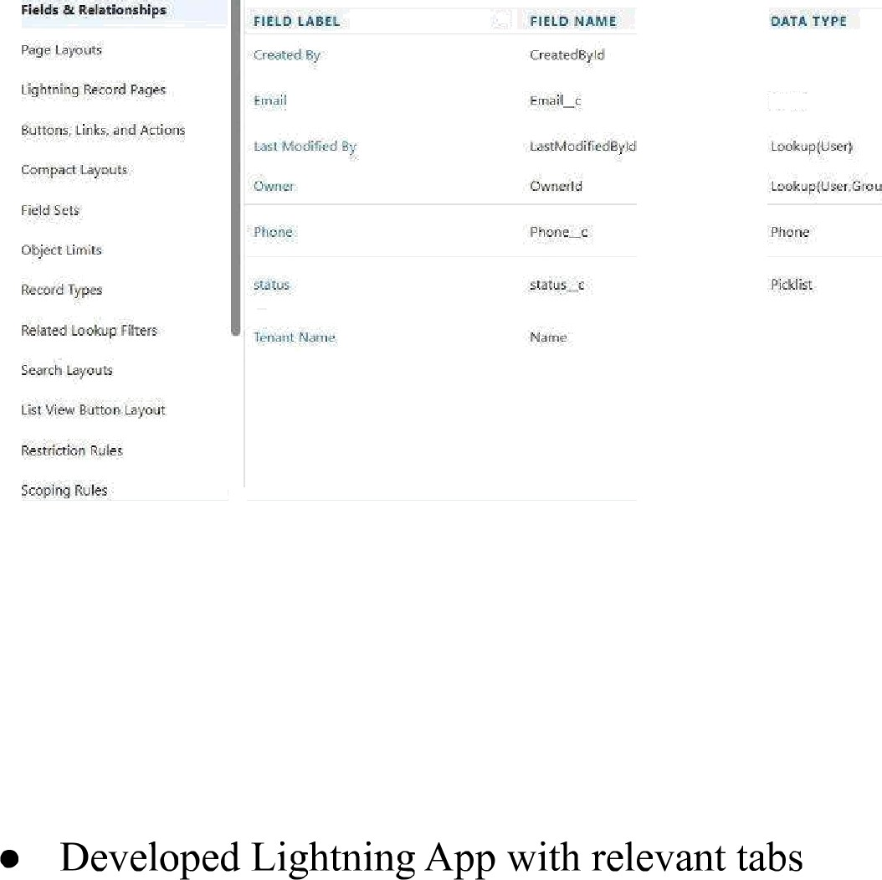

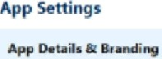Aop Details & Br anding





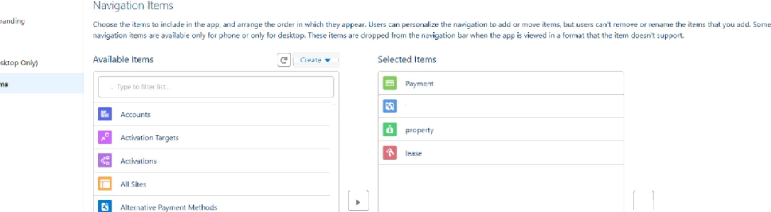





User Profles



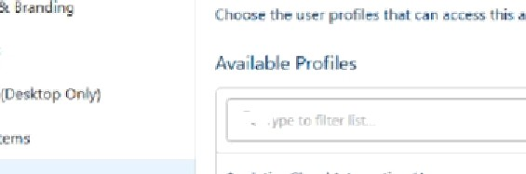





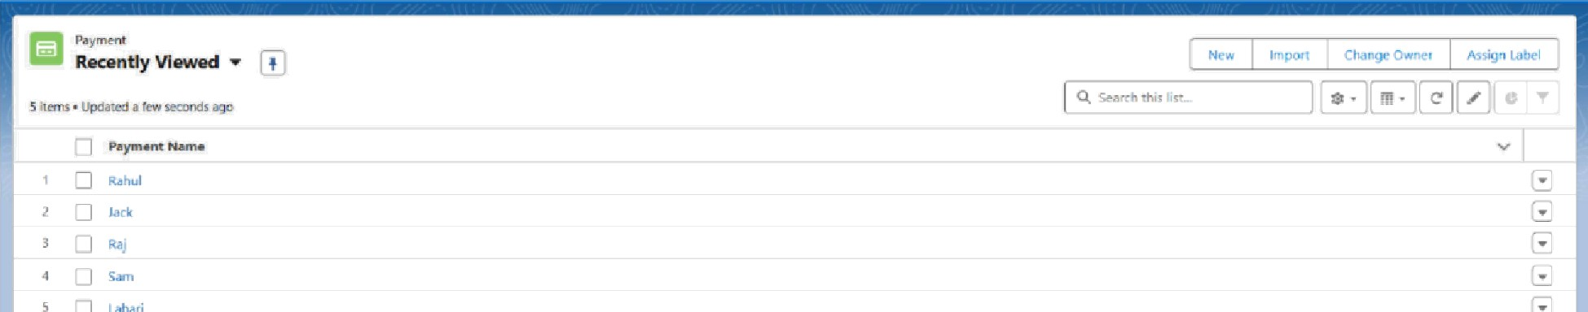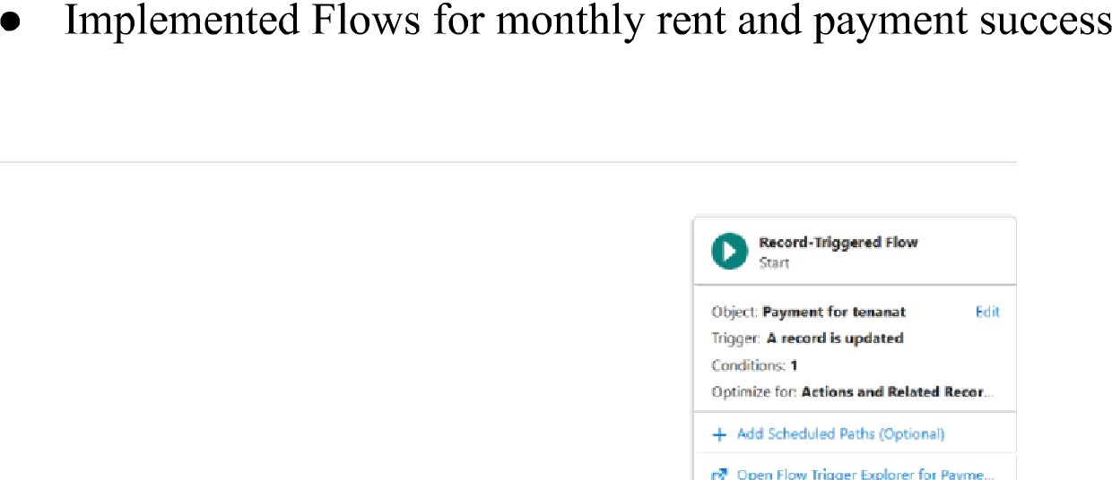

O'°

* To create a validation rule to a Lease Object

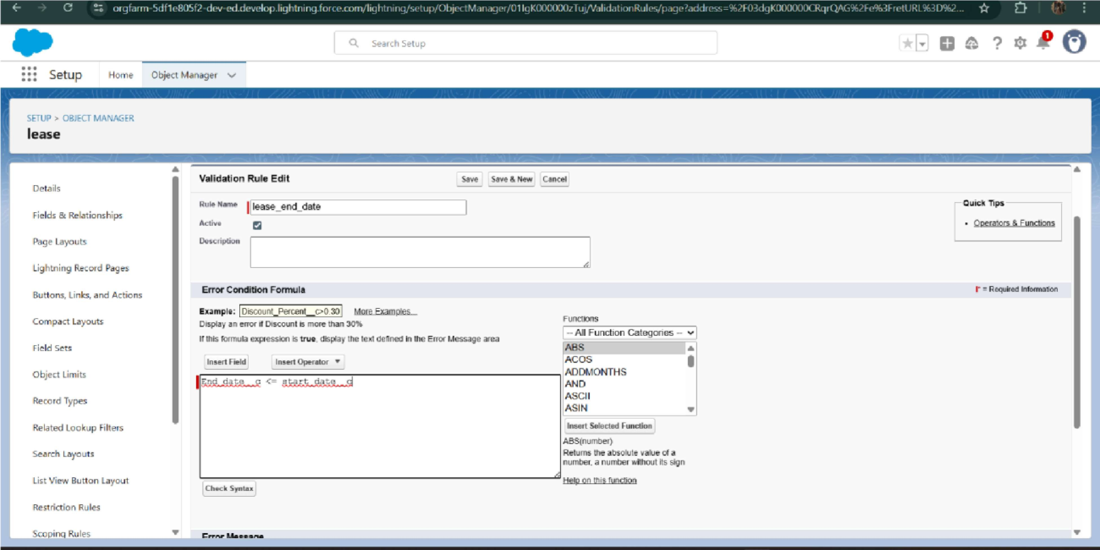

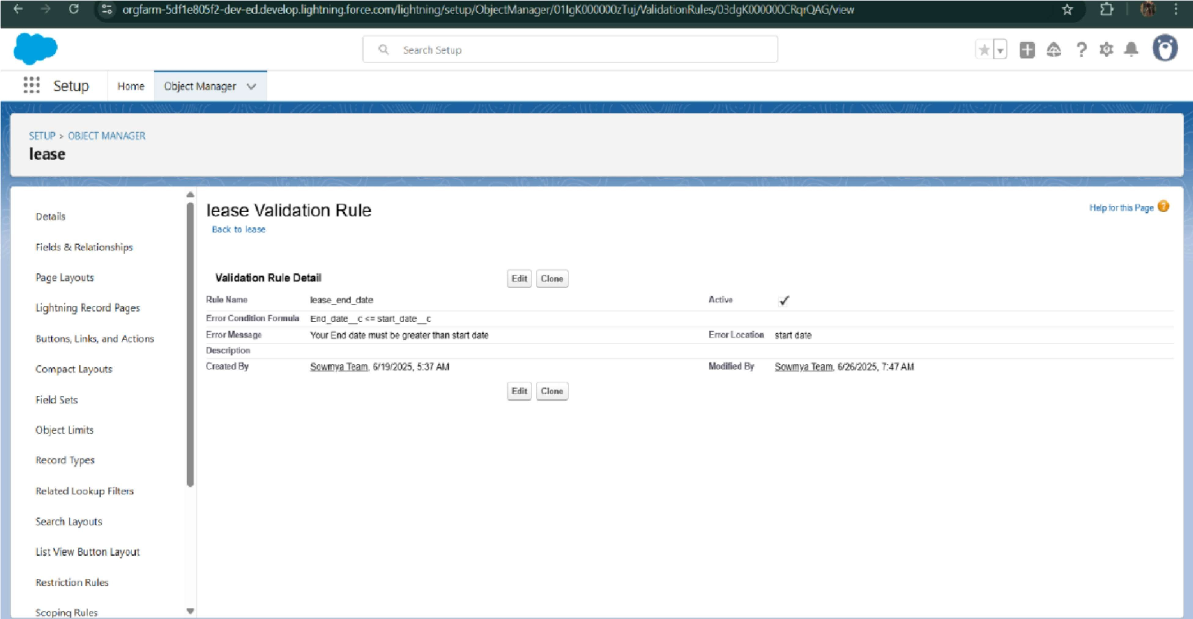



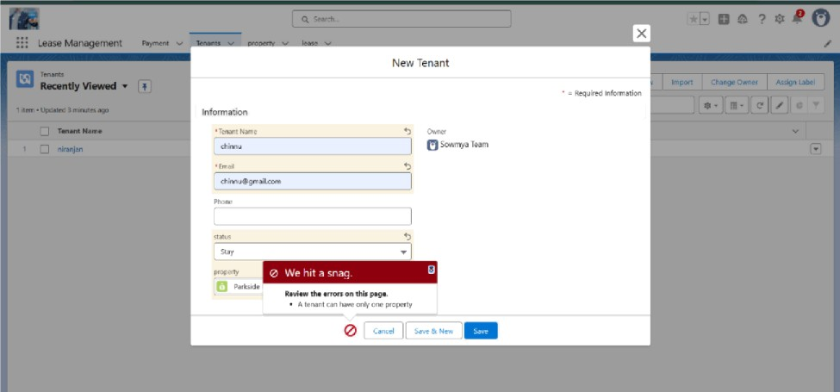

* Scheduled monthly reminder emails using Apex class



#### Built and tested email templates for leave request, approval, rejection, payment, and reminders

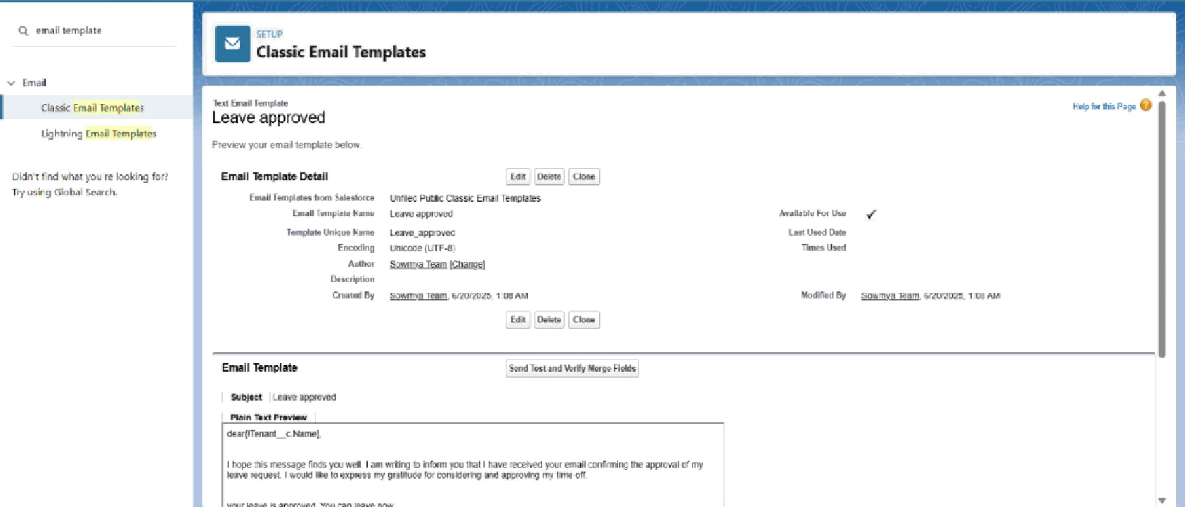

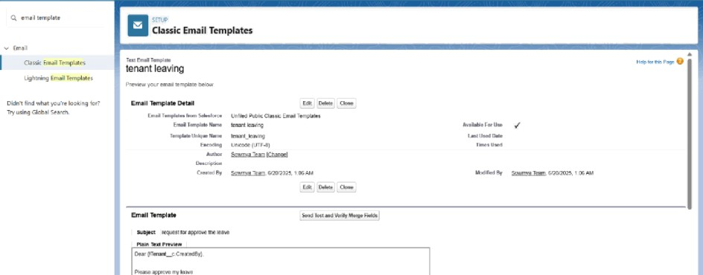



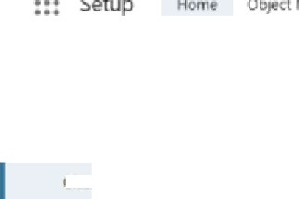

Leave rejected



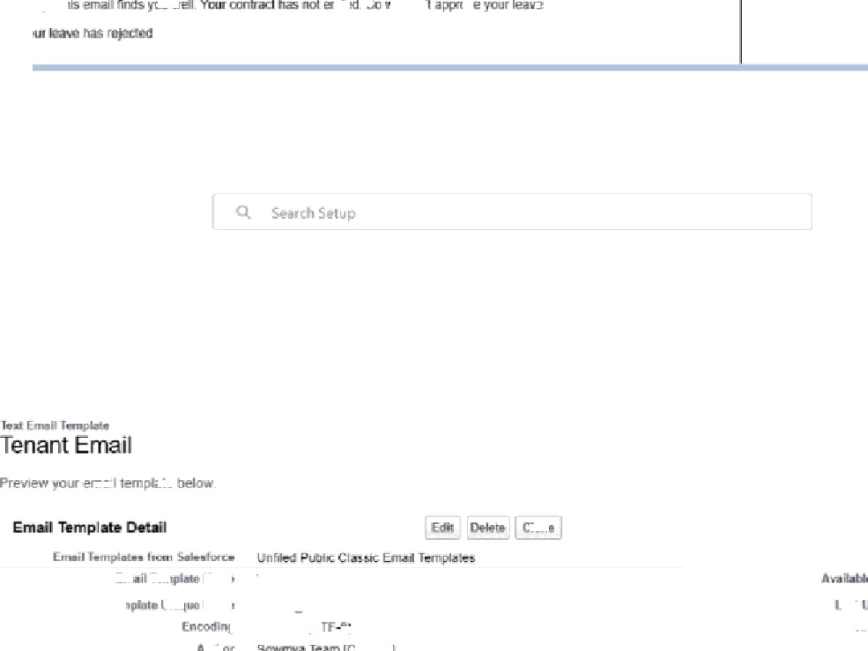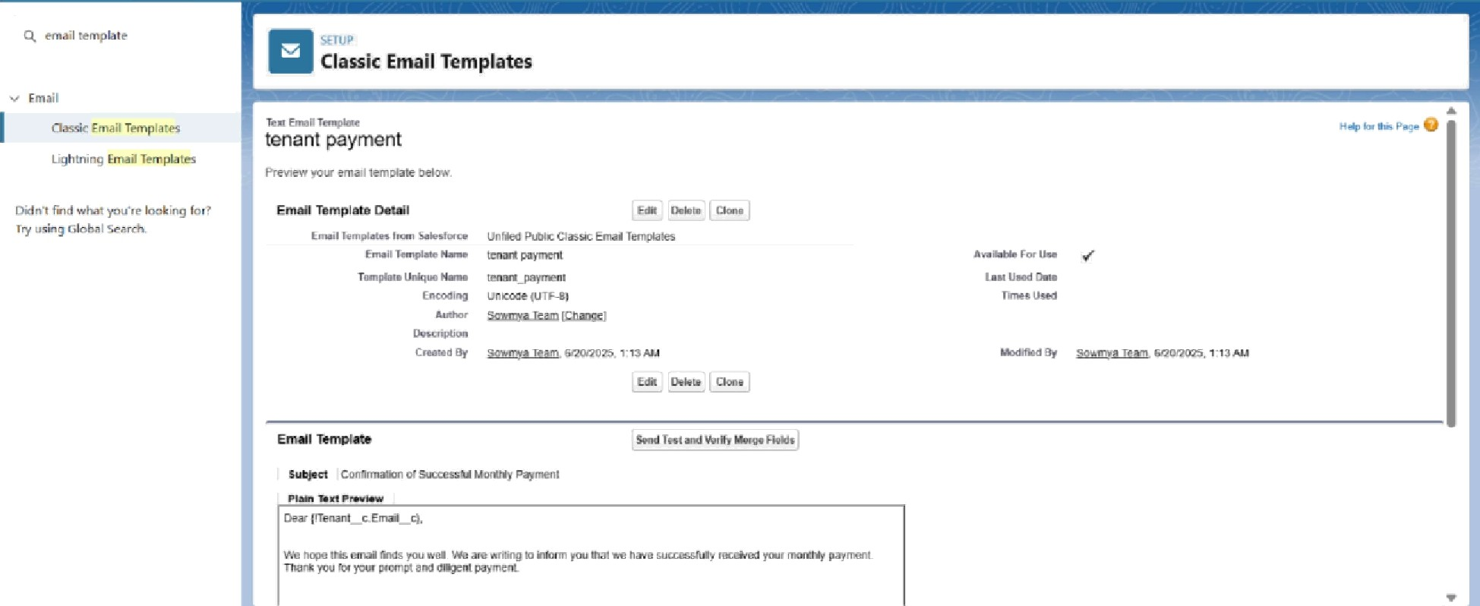

* Approval Process creation

For Tenant Leaving:

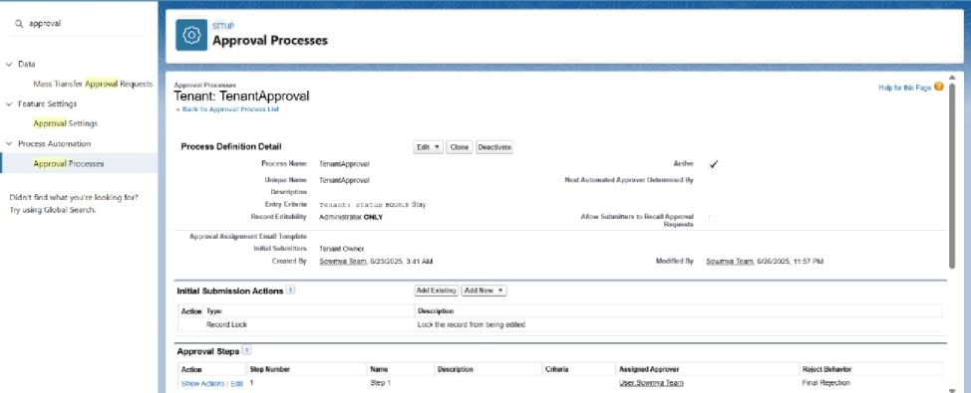

For Check for Vacant:



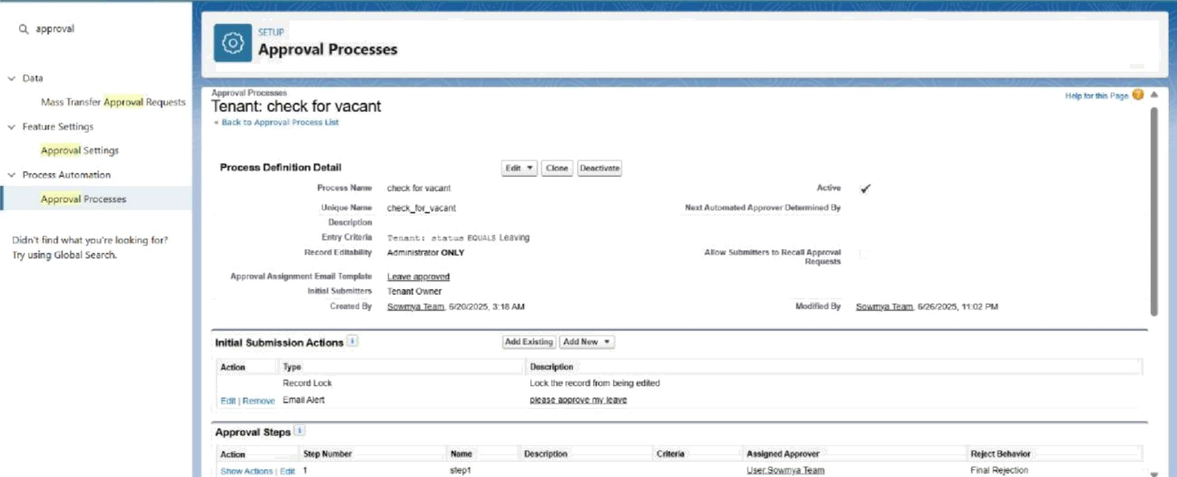

* Apex Trigger

Create an Apex Trigger

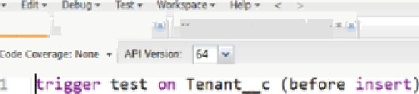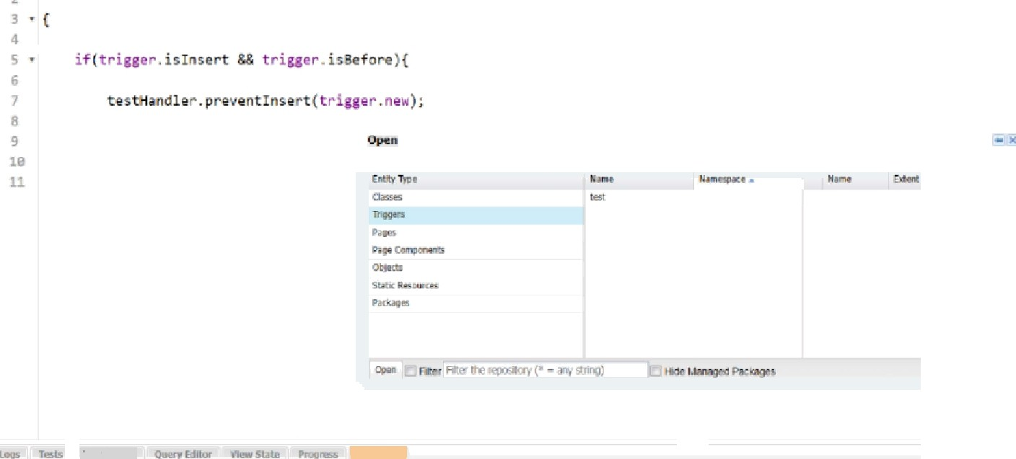

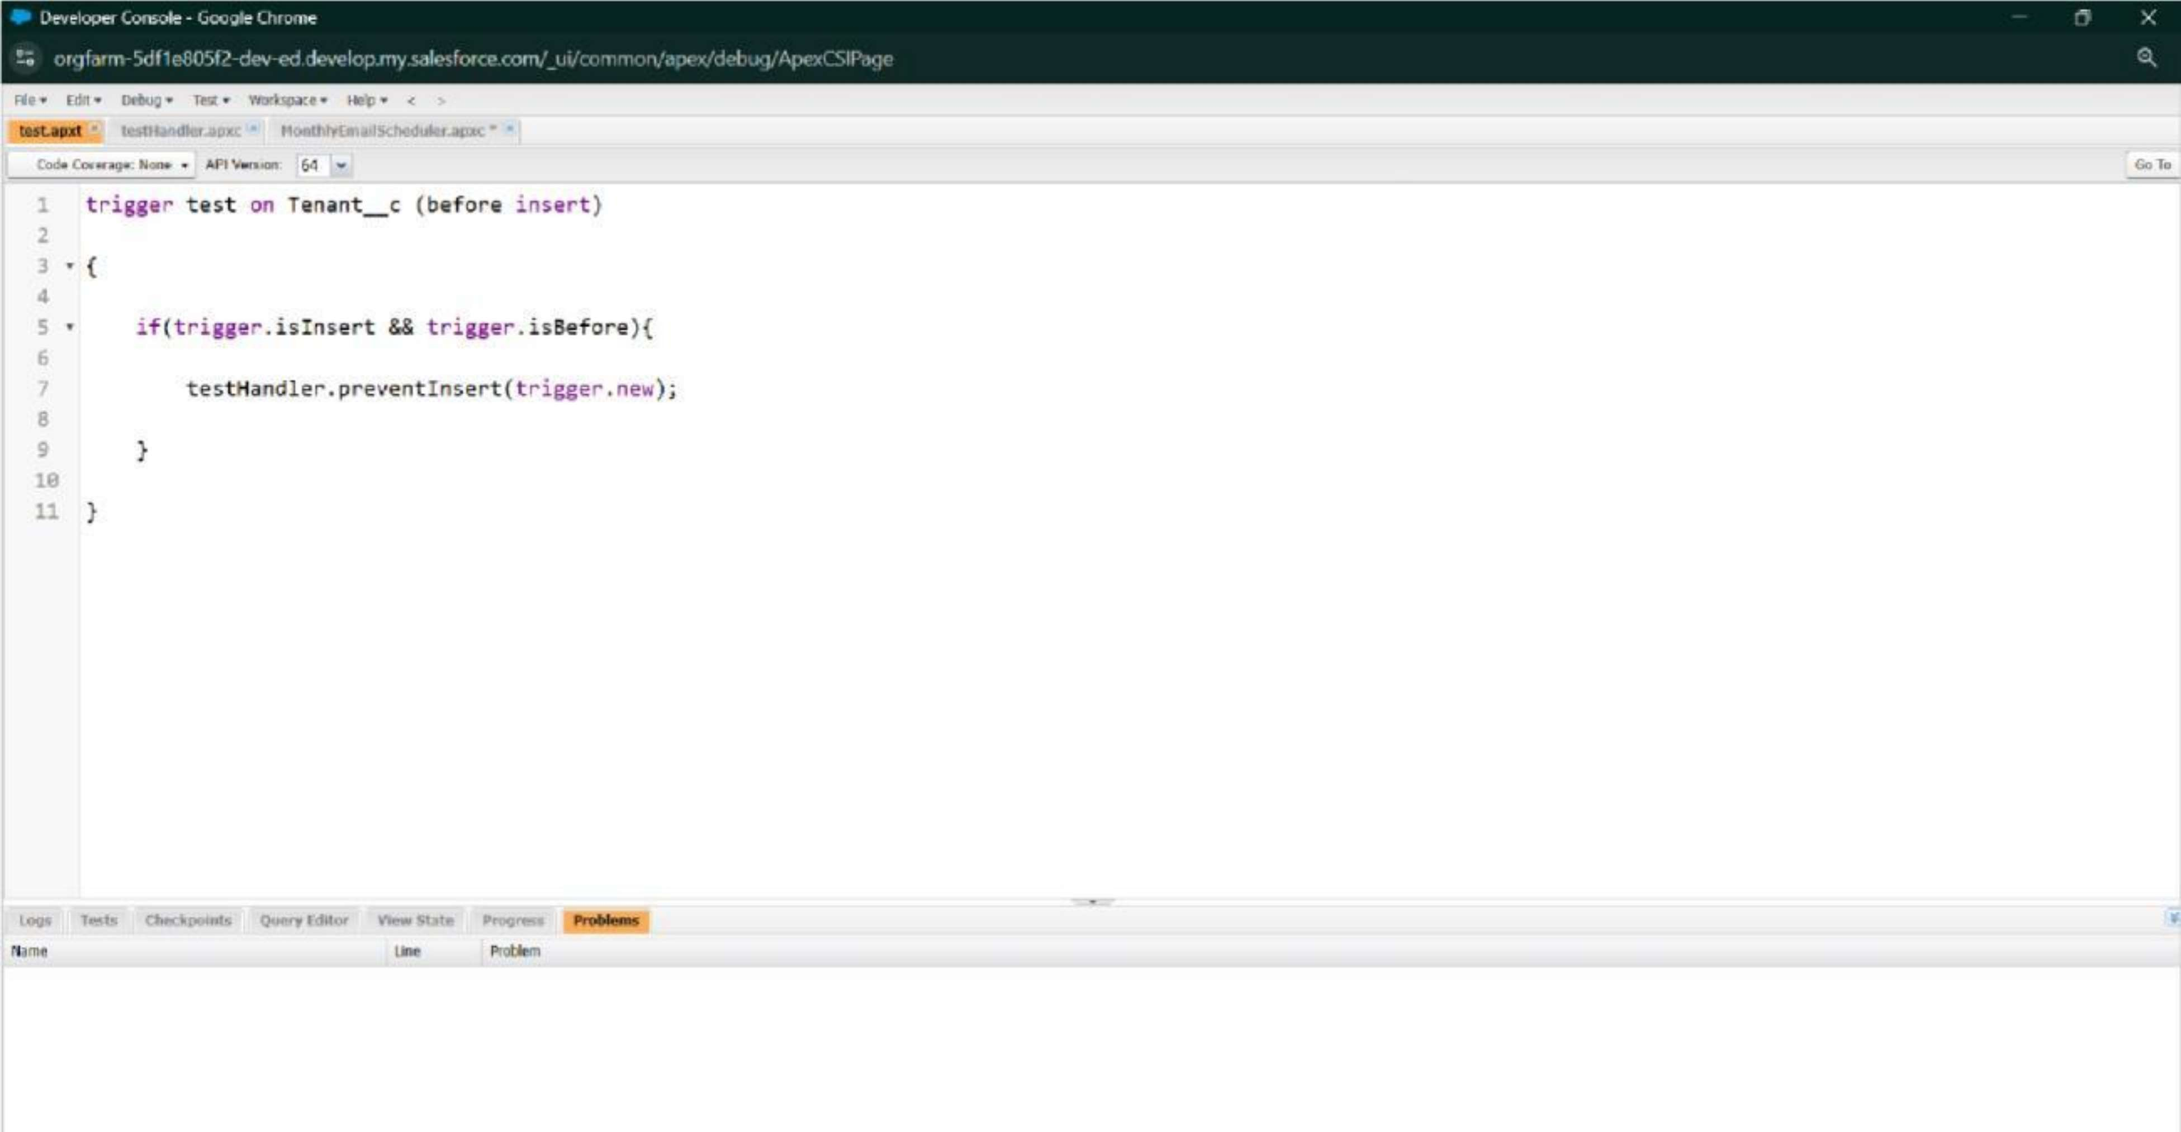

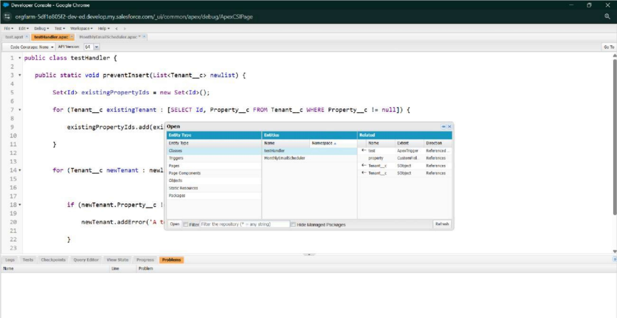



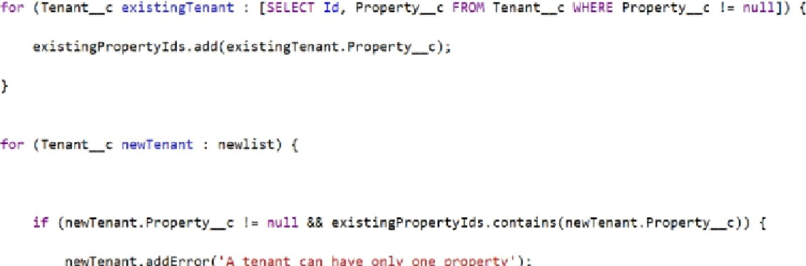7 •

* FLOWS

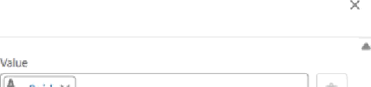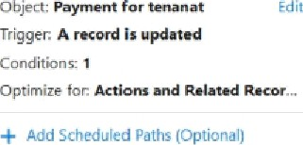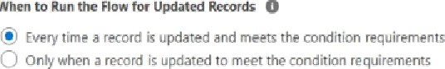



Optimèe Iw

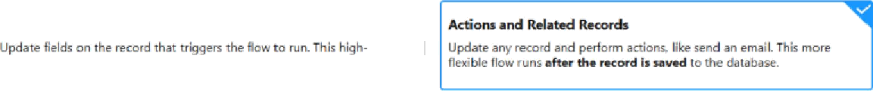

Is this gow making an ætemal callout or connectir+g tø an exæmal system?

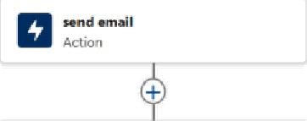



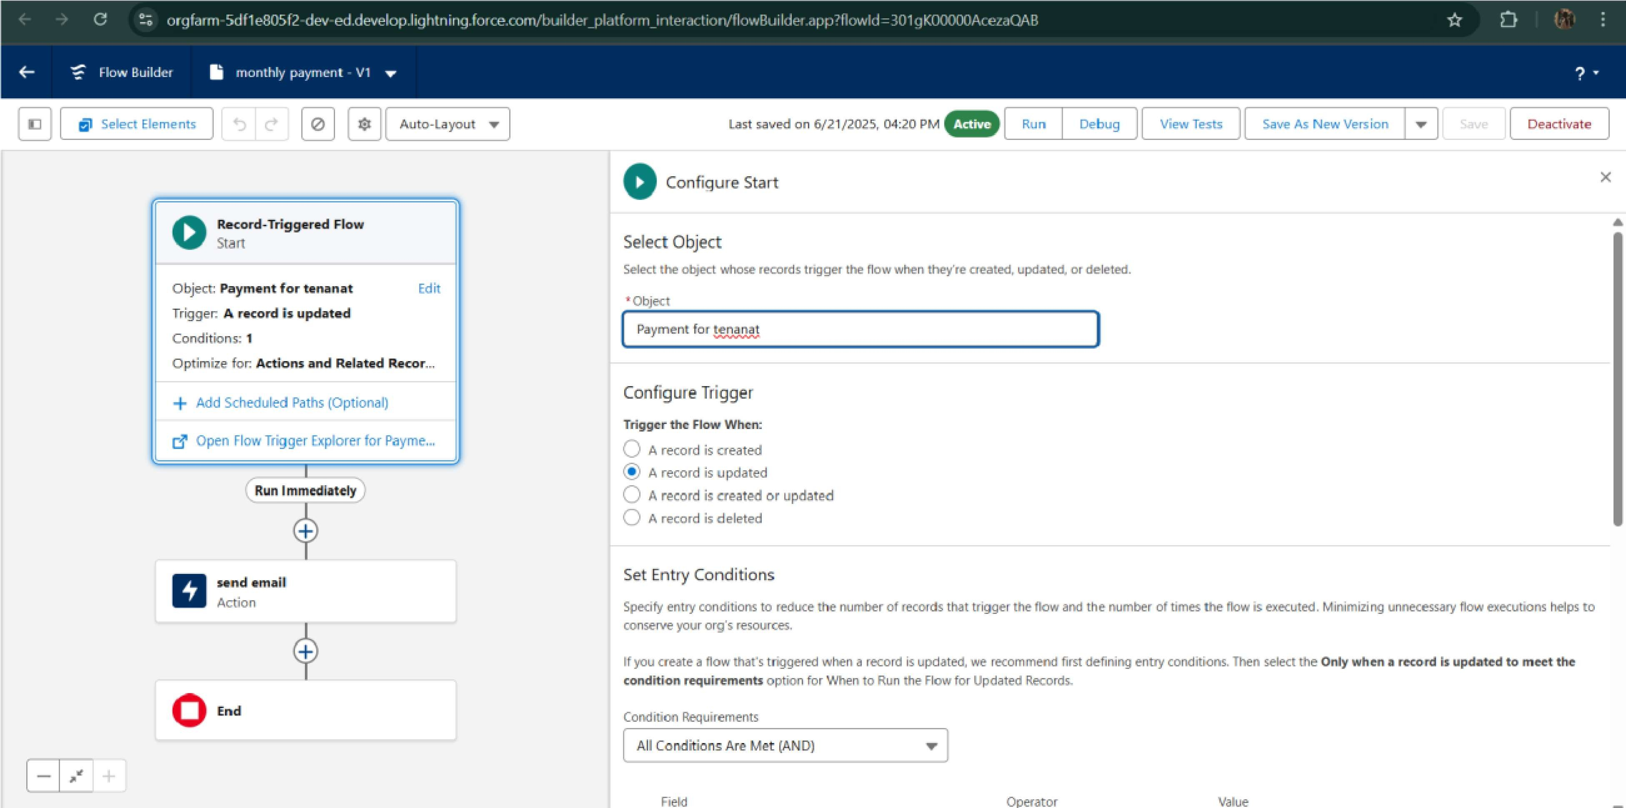

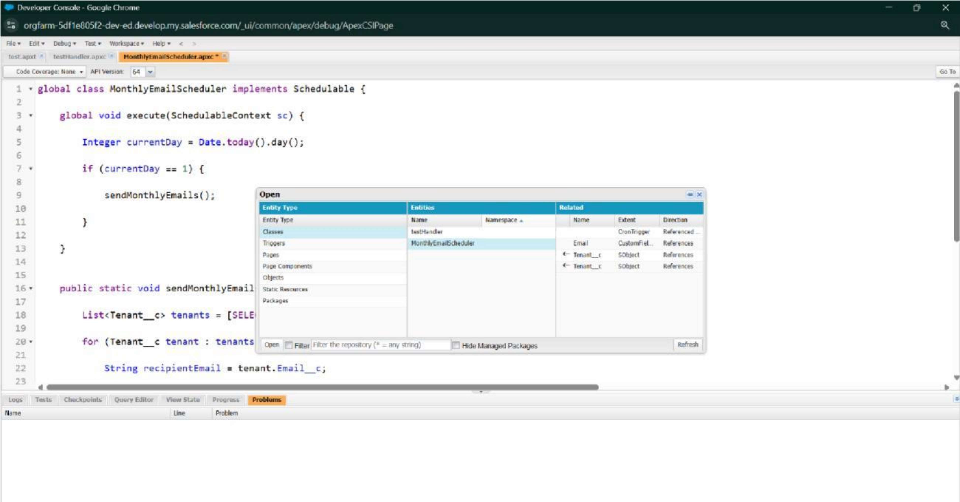



Schedule Apex class



M’onthlyEmailScheduler

I

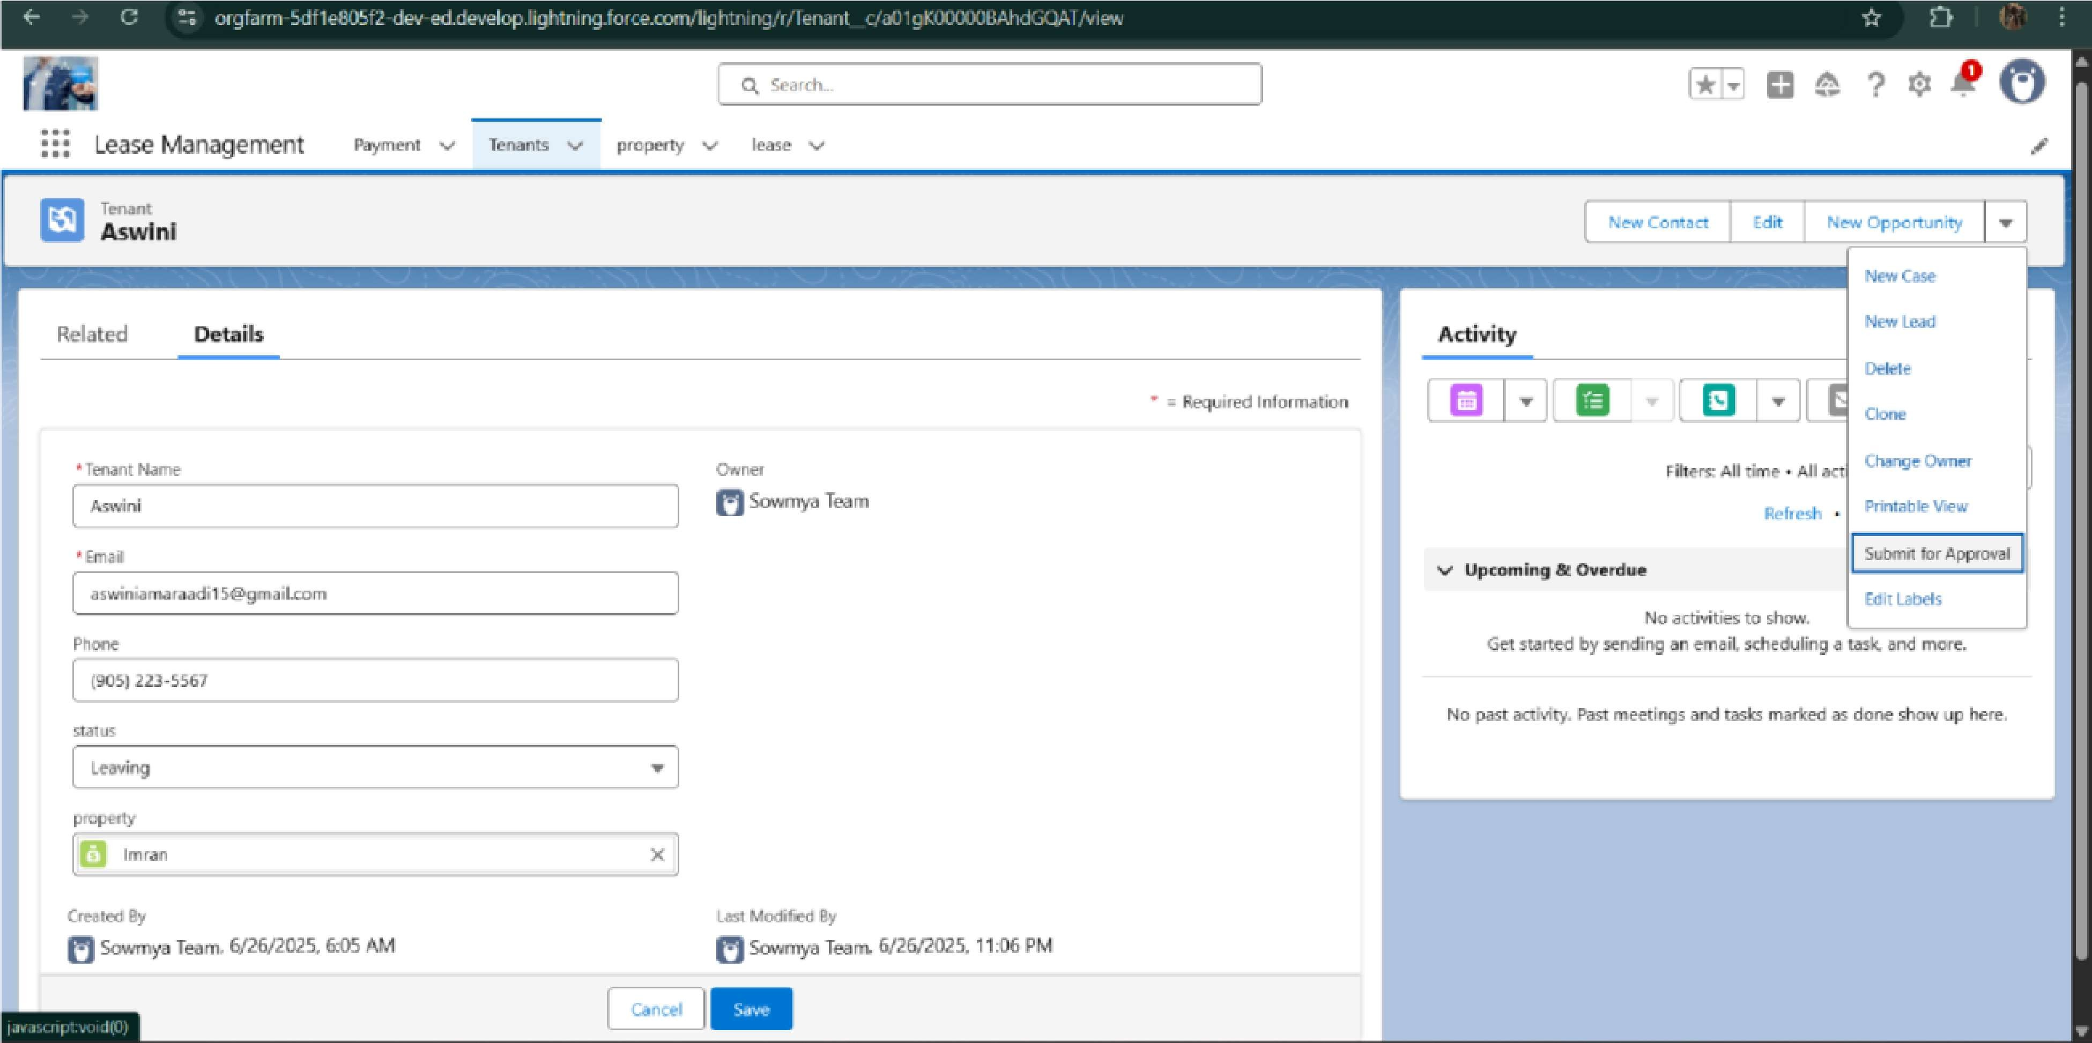

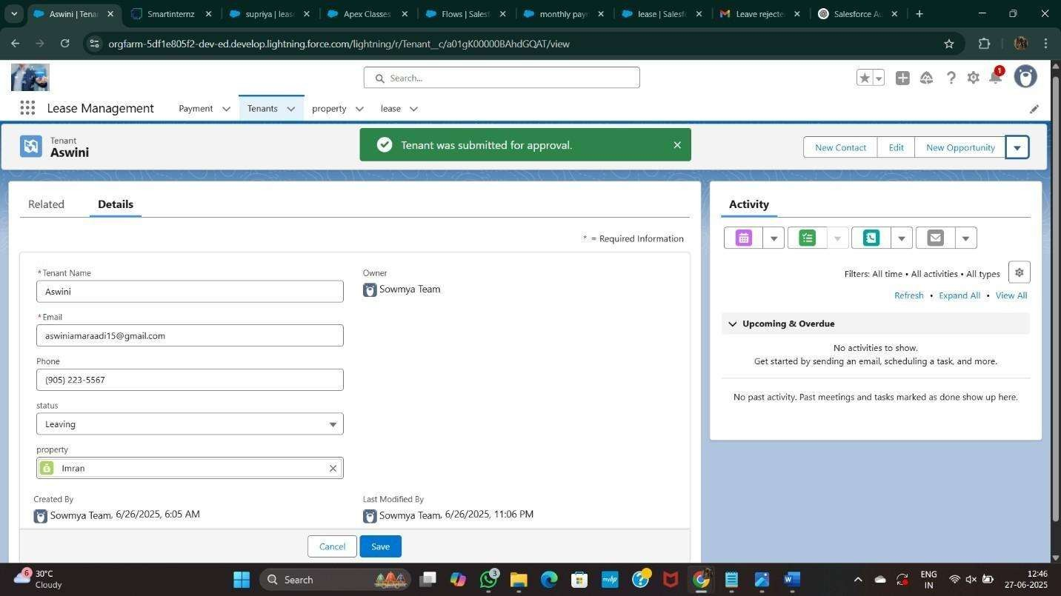

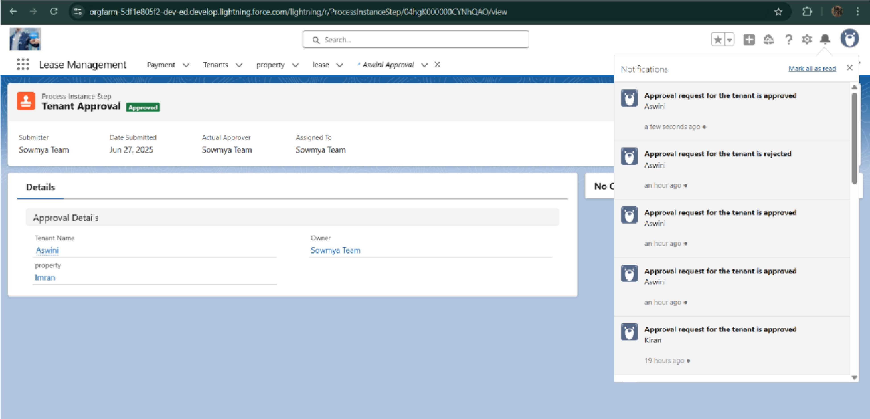

# FUNCTIONAL AND PERFORMANCE TESTING

## Performance Testing

* Trigger validation by entering duplicate tenant-property records

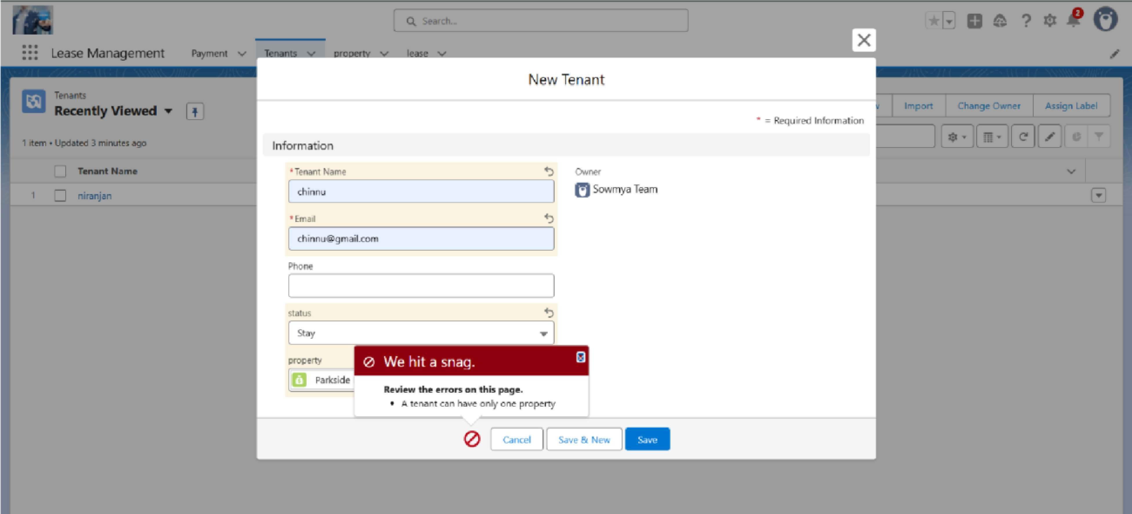

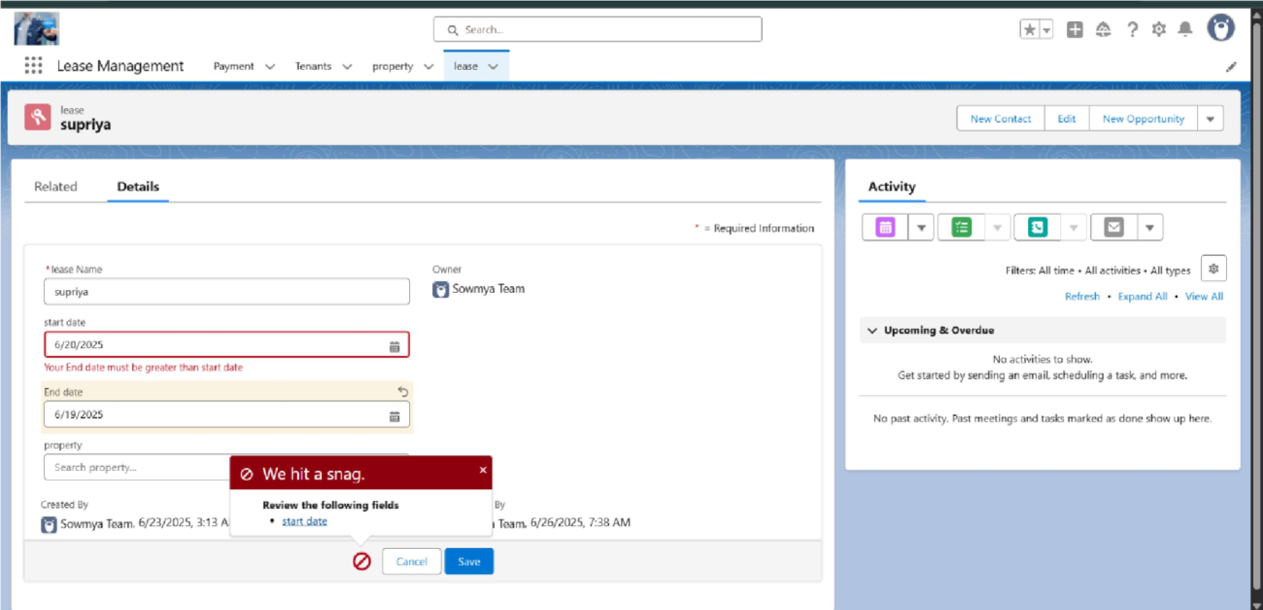

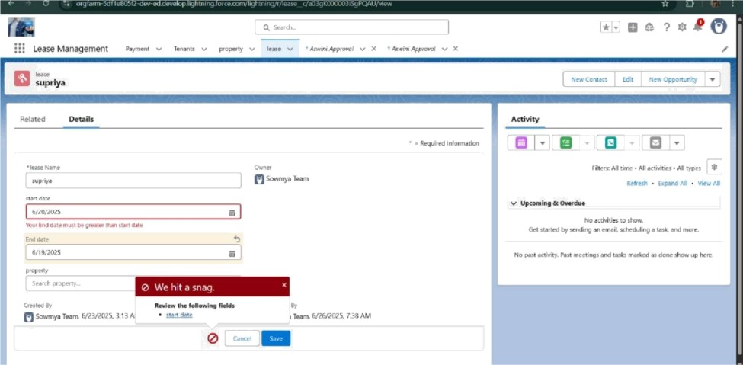

* Test flows on payment update



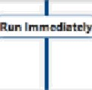



* Approval process validated through email alerts and status updates

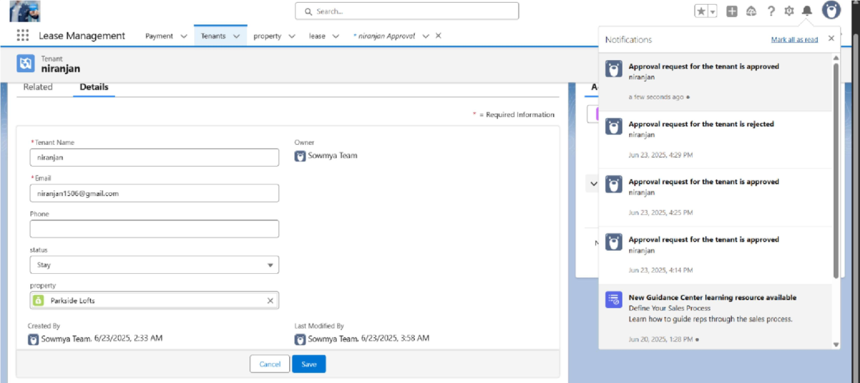

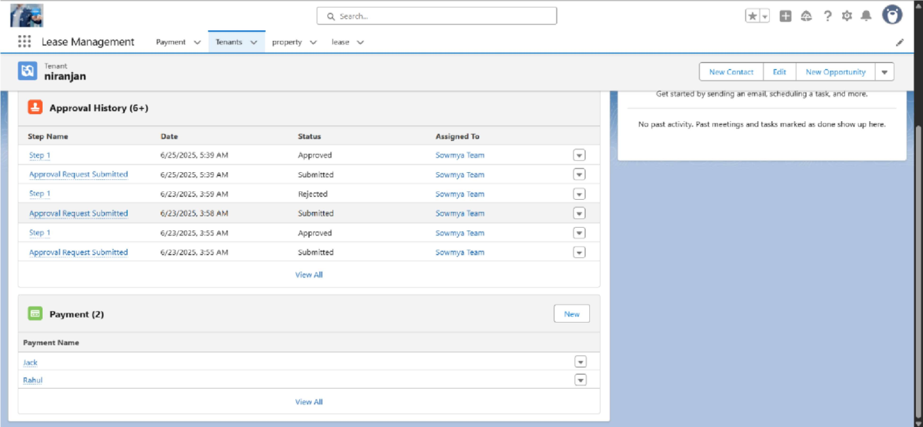

# RESULTS

### Output Screenshots

* Tabs for Property, Tenant, Lease, Payment



p T e OE” T + get s '



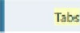’“’“"’"'* Custom Tabs



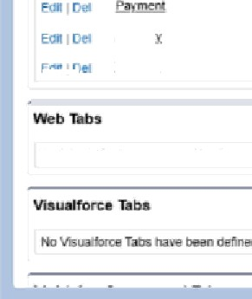

#### Email alerts



; MmeMamgemeM

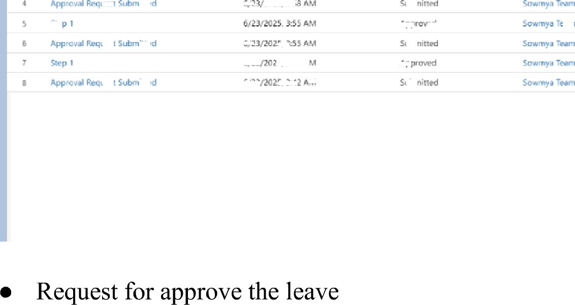

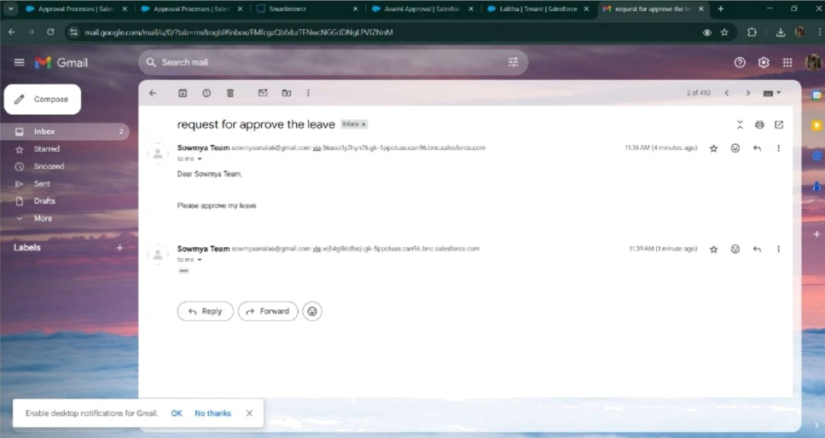

* Leave approved

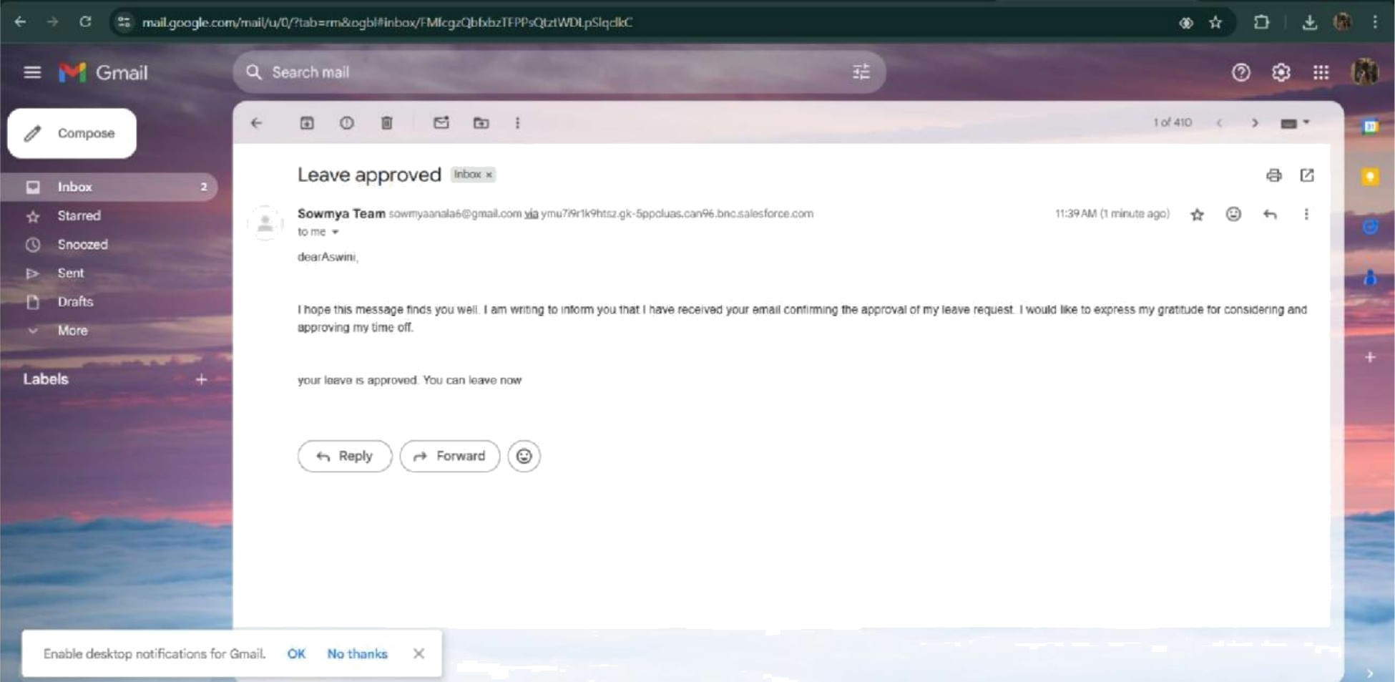

* Leave rejected

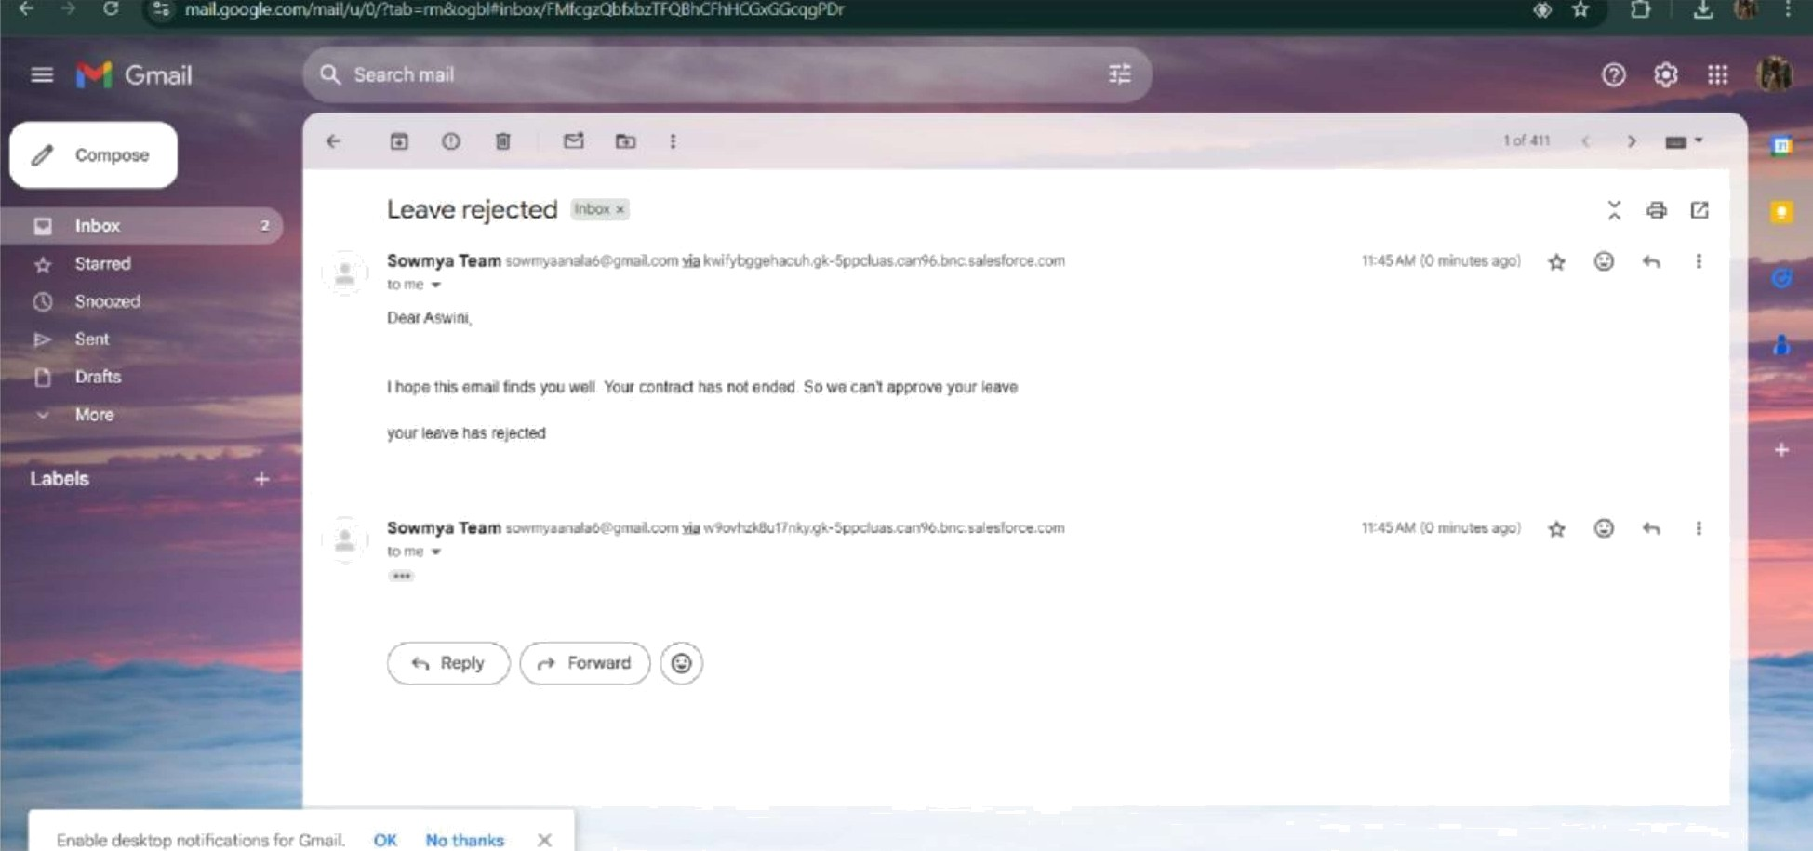

* Flow runs

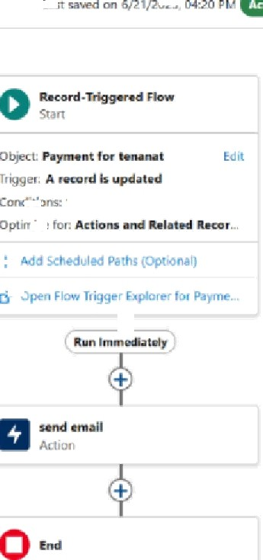

* Trigger error messages

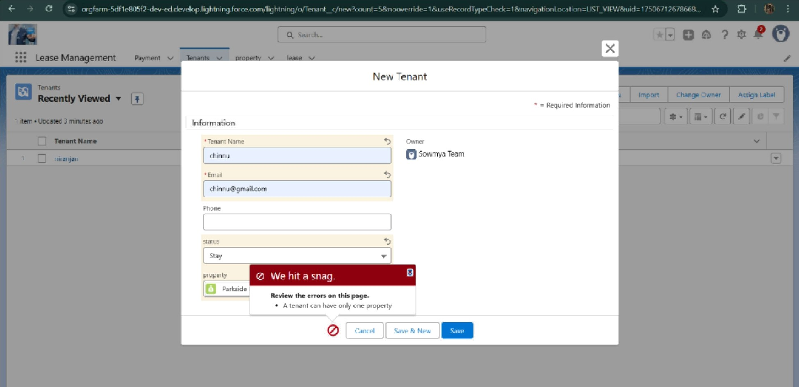

* Approval process notifications

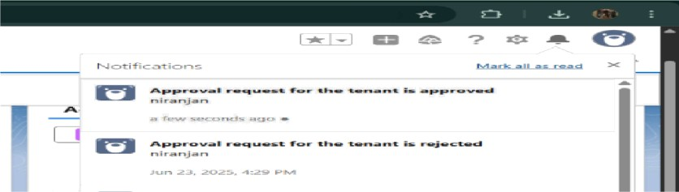

# ADVANTAGES & DISADVANTAGES

**CONCLUSION**

The Lease Management System successfully streamlines the operations of leasing through a structured, automated Salesforce application. It improves efficiency, communication, and data accuracy for both admins and tenants.

**APPENDIX**

* + **Source Code:** Provided in Apex Classes and Triggers

##### Test.apxt:

trigger test on Tenant c (before insert) ( if (trigger.isInsert && trigger.isBefore)( testHandler.preventInsert(trigger.new);

##### testHandIer.apxc:

public class testHandler ( public static void preventInsert(List<

Tenant c> newlist)

Set<Id> existingPropertyIds

= new Set<Id>()

for (Tenant c existingTenant : [SELECT Id, Property c FROM Tenant c WHERE Property c != null]) (

existingPropertyIds.add(existingTenant.Property c;

} for (Tenant c newTenant :

newlist) (

if(newTenant.Property c != null && existingPropertyIds.contains(newTenant.Property c)) { newTenant.addError('A

tenant can have only one property');

##### MothIyEmaiIScheduler.apxc:

global class MonthlyEmailScheduler implements Schedulable ( global void execute(Schedu1ab1eContext sc) { Integer currentDay = Date.today().day(); if(currentDay == 1) { sendMonthlyEmails();

} public static void sendMonthlyEmails() ( List<Tenant c> tenants = [SELECT Id, Email c FROM Tenant c]; for (Tenant c tenant :

tenants) (

String recipientEmail = tenant.Email c;

String emailContent = 'I trust this email finds you well. I am writing to remind you that the monthly rent is due Your timely payment ensures the smooth functioning of our rental arrangement and helps maintain a positive living environment for all.';

String emailsubject = 'Reminder: Monthly Rent Payment Due",

Messaging.SingleEmai1Message email = new Messaging.SingleEmai1Message(); email.setToAddresses(new String[](recipientEmail}); email.setSubject(emailsubject); email.setP1ainTextBody(emailContent);

Messaging.sendEmail(new Messaging.Sing1eEmai1Message[](email});